Simulation and Analysis of Uniform and NonUniform Quantization Using MATLAB
AIM :
• To simulate uniform and non-uniform quantization techniques using MATLAB.
• To calculate and compare the Signal-to-Quantization-Noise Ratio (SQNR) of both techniques.
CODE:

clc;
clear;
close all;

% Parameters
N = 1000;
t = linspace(0, 1, N);
x = sin(2*pi*5*t);
L = 8; % Number of quantization levels

% Uniform Quantization
xmin = -1;
xmax = 1;
delta = (xmax - xmin)/L;

x_uniform = xmin + delta/2 + ...
delta*floor((x - xmin)/delta);

x_uniform(x_uniform > xmax - delta/2) = xmax - delta/2;
x_uniform(x_uniform < xmin + delta/2) = xmin + delta/2;

% Non-Uniform Quantization (Mu-law Companding)
mu = 255;

% Compress the signal
x_compressed = sign(x).* ...
log(1 + mu*abs(x))/log(1 + mu);

% Quantize the compressed signal
delta_mu = 2/L;
xq_compressed = -1 + delta_mu/2 + ...
delta_mu*floor((x_compressed + 1)/delta_mu);

xq_compressed = min(max(xq_compressed, ...
-1 + delta_mu/2), 1 - delta_mu/2);

% Expand the quantized signal
x_nonuniform = sign(xq_compressed).* ...
((1 + mu).^abs(xq_compressed) - 1)/mu;

% Quantization Errors
error_uniform = x - x_uniform;
error_nonuniform = x - x_nonuniform;

% SQNR Calculation
SQNR_uniform = 10*log10( ...
sum(x.^2)/sum(error_uniform.^2));

SQNR_nonuniform = 10*log10( ...
sum(x.^2)/sum(error_nonuniform.^2));

% Plot Results
figure;

subplot(3,1,1);
plot(t,x,'b');
title('Original Signal');
xlabel('Time (s)');
ylabel('Amplitude');
grid on;

subplot(3,1,2);
stairs(t,x_uniform,'r');
hold on;
plot(t,x,'b');
title('Uniform Quantization');
xlabel('Time (s)');
ylabel('Amplitude');
legend('Quantized','Original');
grid on;

subplot(3,1,3);
plot(t,x,'b');
hold on;
plot(t,x_nonuniform,'r');
title('Non-Uniform Quantization (Mu-law)');
xlabel('Time (s)');
ylabel('Amplitude');
legend('Original','Quantized');
grid on;

% Display Results
fprintf('Uniform Quantization SQNR = %.2f dB\n', ...
SQNR_uniform);

fprintf('Non-Uniform Quantization SQNR = %.2f dB\n', ...
SQNR_nonuniform);

OUTPUT:

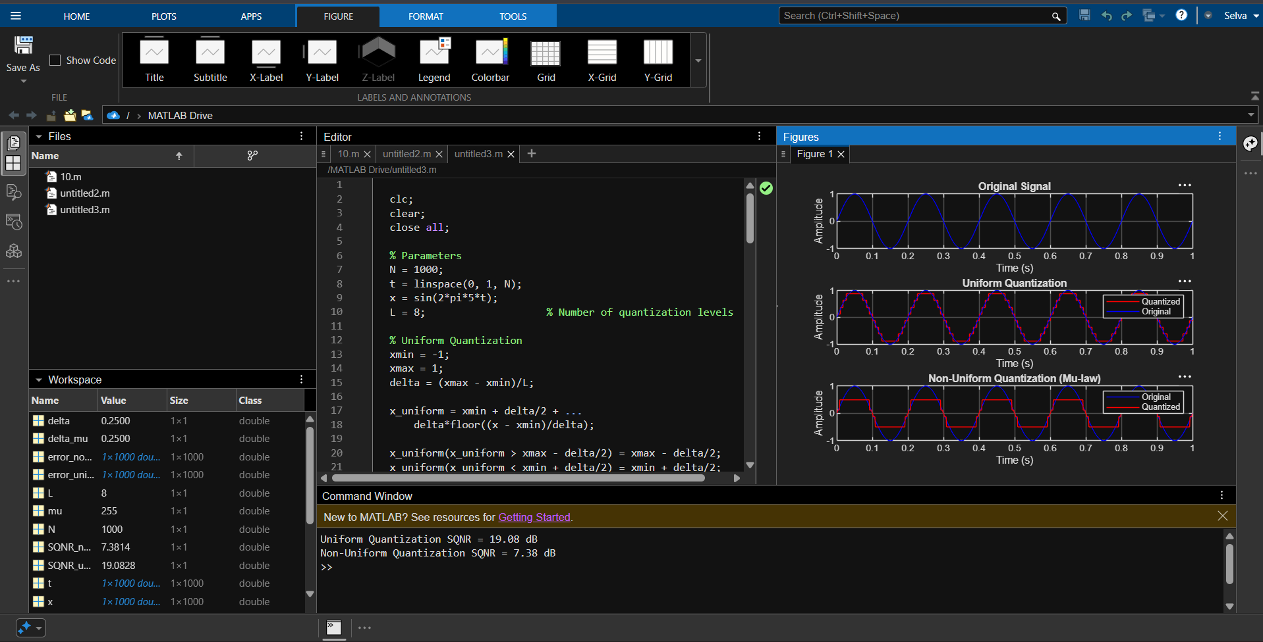

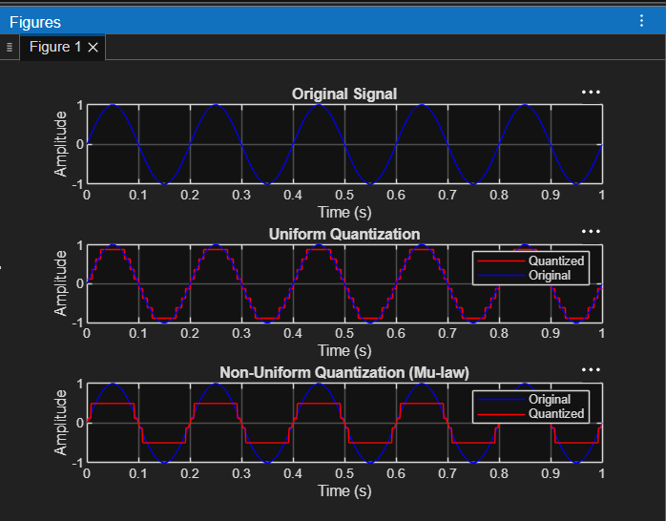

RESULT :
• The FM signal was successfully generated, and Gaussian white noise was added using MATLAB.
• The noisy signal was demodulated, and its performance was analyzed by comparing the input and output SNR.

